DP-203 CloudLabs – Learner’s Guide.

Contents

Get Access to Lab environments. 1

Environment Duration and Uptime Limits 3

How to Stop VMs and Pause SQL Pool. 4

Stopping/Starting the VMs. 4

Pausing/Resuming the SQL Pool. 5

Best Practices: 6

Lab Guide preview: 6

This document is designed to help you get access to DP-203 environment and manage the course labs.

## Get Access to Lab environments.

Your instructor should have provided you a unique link to signup for DP-203 Lab. If you do not have sign up information, please contact your instructor or other contact as applicable.

Please follow below instructions to register for lab environment. You can use Microsoft Edge Chromium, Google Chrome, or Firefox browsers. .

1. Open the provided registration URL <https://bit.ly/XXXXXX> in a supported browser , provide the required information in the fields.
2. Provide the provided Activation code **ACTIVATEXXXX** and click on **Submit.**

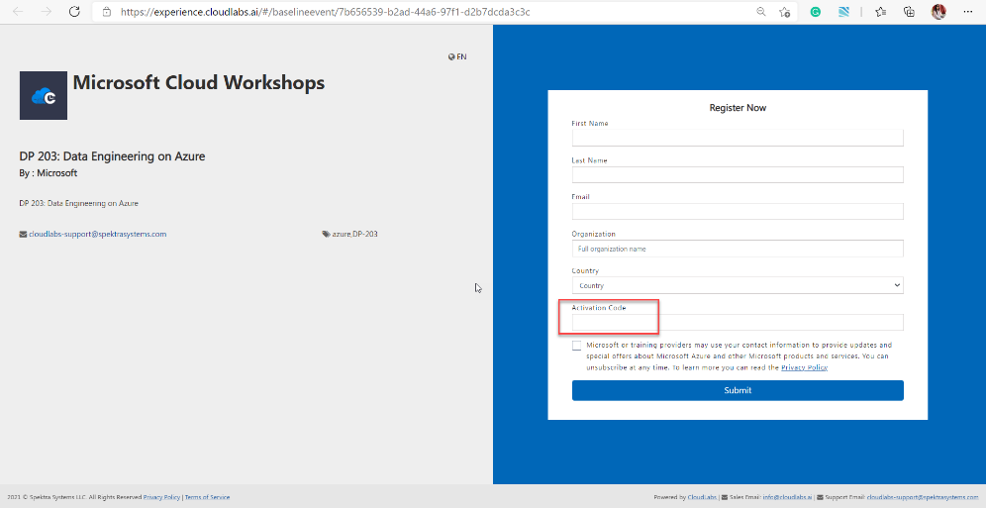

1. As soon as you signup and you will get access to lab launch page. Please save this unique URL, you will need this throughout the course. You will also get this link in your registered email address from [noreply@cloudlabs.ai](mailto:noreply@cloudlabs.ai) (Be sure to check junk email)

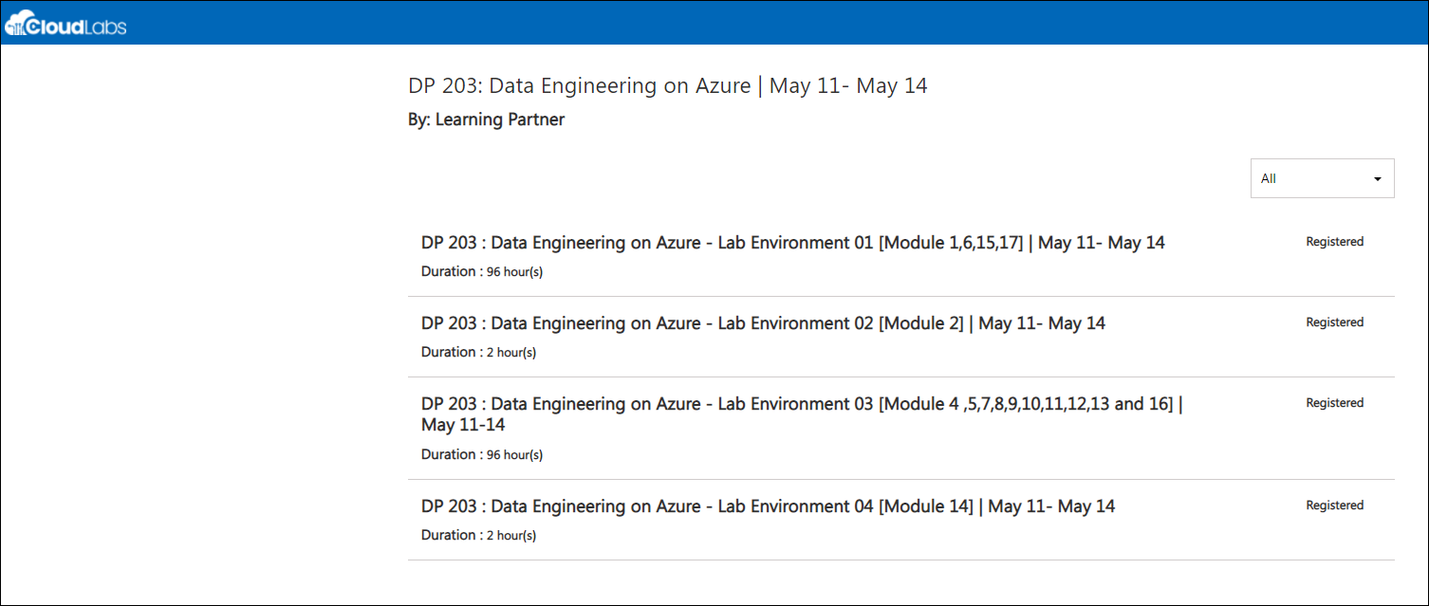

1. **Understand the Lab Environment:** DP-203 includes 17 modules, in which 16 modules includes labs and 1 module is whiteboard activity Only.  There are 4 types of lab environments used in the entire course, as you can see in the above screenshot. Each lab environment can used to perform one or more lab module exercises as described below.
   1. **Lab Environment and respective lab module mapping:**
      1. **Lab Environment 1:** Includes Module 1,6,15 ,17
      2. **Lab Environment 2:** Includes Module 2
      3. **Lab Environment 3 :** Includes Modules 4,5,7,8,9,10,11,12,13,16 and
      4. **Lab Environment 4:** Includes  Module 14
2. Module 03 does not need a lab environment as it is a whiteboard activity.
3. Each environment can be activated independently, and you may be running multiple environments at a time. For example, you can complete Module 1 using Lab environment 1 and activate Lab environment 2 to complete module 2 while lab environment 1 continues to stay active in parallel.
4. Please click on the respective environment to launch the instance. This will take you to a Lab launch page. Click on **Launch Lab** to get the environment.

Once you launch the lab the timer for the environment starts.

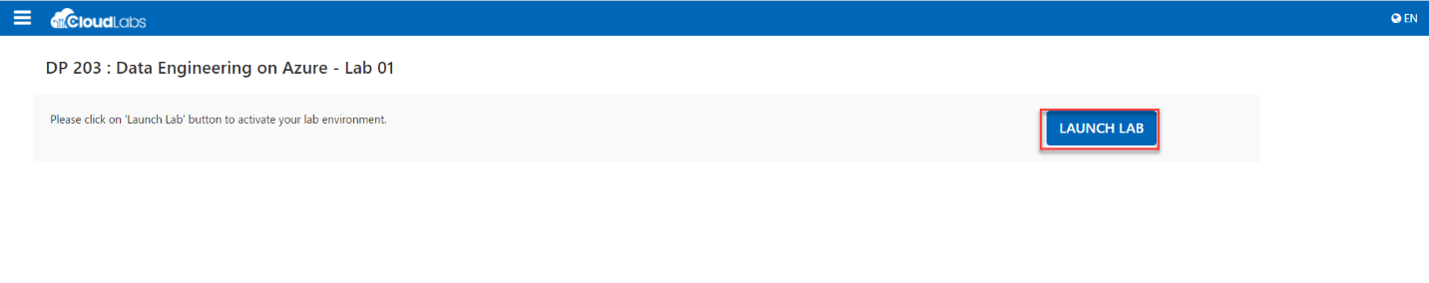

1. The environment will be loaded on a browser with lab guide on the right and VM on the left.

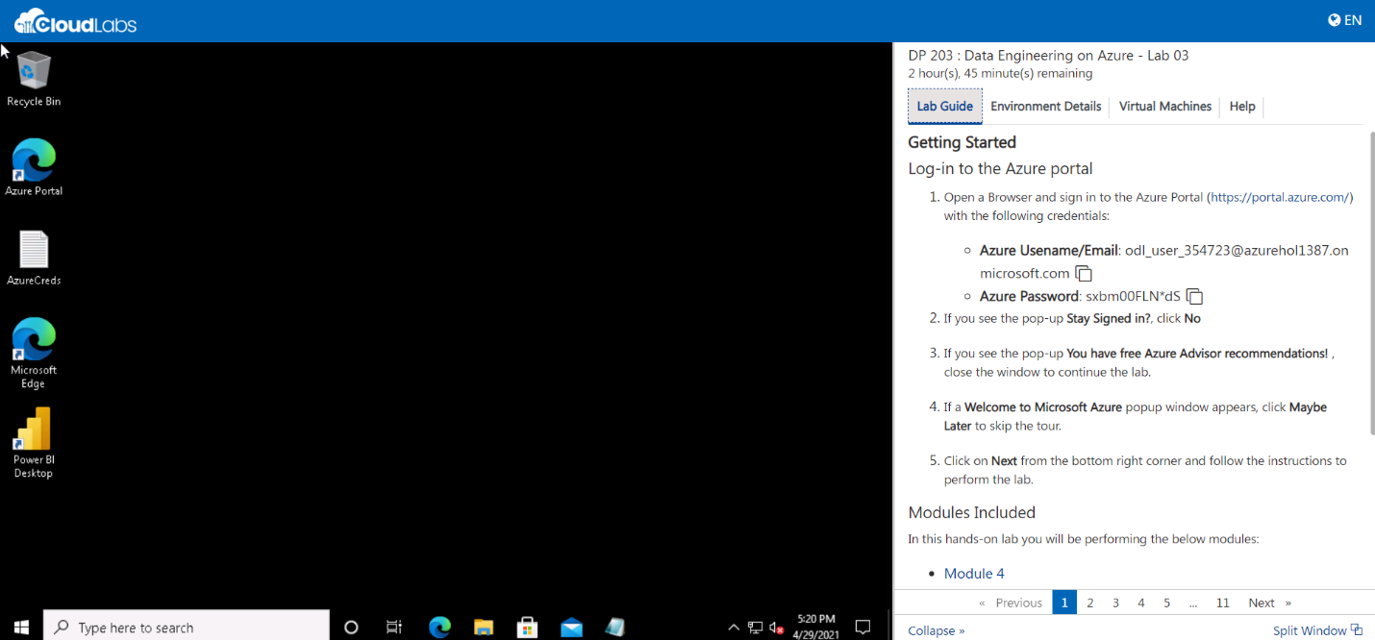

1. You can now perform the lab. Please be sure to go through this document till the end before starting the lab exercises.

## Environment Duration and Uptime Limits

Each Lab environment has two characteristics. Let us take a moment to understand them.

* + 1. **Environment Duration**: Environment will get deleted after a specified number of hours. E.g, Lab environment 1 duration is 96 Hours since it will be used for all 4 days to complete various lab modules.
    2. **Environment Uptime**: Lab environments typically include Virtual Machines and SQL Pool. VMs and SQL Pool have uptime limits to keep the cloud costs under control.  E.g, Lab environment 1 includes 9 Hours of SQL Pool and VM uptime limit (2 hours per lab module). You will find the resource in stopped/Pause stopped at the time of activation.

Please start them when you are ready to start the lab. Lab guides include the required instructions. Once the uptime limit is reached, all resources will remain in stopped/pause resource.

**Please see the duration and uptime limits configured for DP-203 Lab environment below:**

* 1. **Lab Environment 1:** Includes Module 1,6,15 ,17
* Duration : 96 hours
* Up time : 09 hours
  1. **Lab Environment 2:** Includes Module 2
  + Duration: 2 hours
  + Up time : No uptime since environment will be deleted after 2 hours.
  1. **Lab Environment 3 :** Includes Modules 4,5,7,8,9,10,11,12,13,16
  + Duration : 96 hours ,
  + Uptime – 18 hours
  1. **Lab Environment 4:** Includes Module 14
  + Duration –2 hours,
  + Uptime –No uptime since environment will be deleted after 2 hours.

## How to Stop VMs and Pause SQL Pool.

Please see following instructions to stop the VMs and pause SQL Pool during the workshops to stay under the uptime limits.

### Stopping/Starting the VMs.

1. Please start the Virtual machine before you start the lab steps. To do this, navigate to Virtual Machines tab in the lab environment page. Click on **Start** Icon.

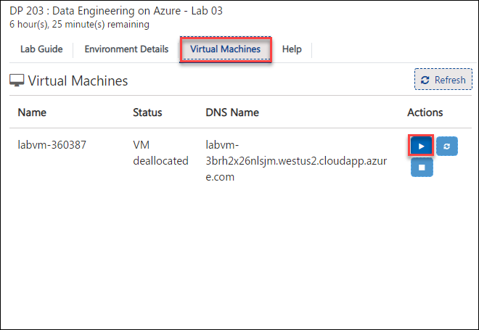

1. Please stop the VMs once you are done using a particular lab environment. You can stop the VM using the lab environment page. Please navigate to Virtual Machines page and click **Stop** icon.

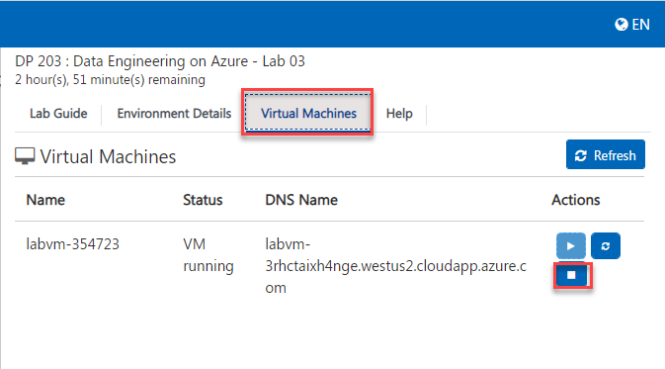

### Pausing/Resuming the SQL Pool.

1. Please resume the SQL Pool before you start the lab. SQL pool can be resumed from the azure portal under the resource group named DP203.

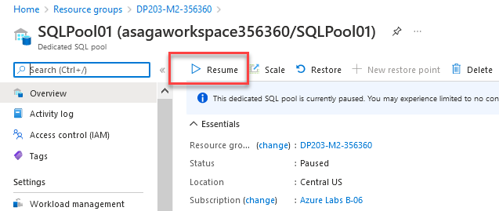

2. Please pause the SQL Pool once you are done using a particular lab environment. SQL pool can be paused from the azure portal under the resource group named DP203.

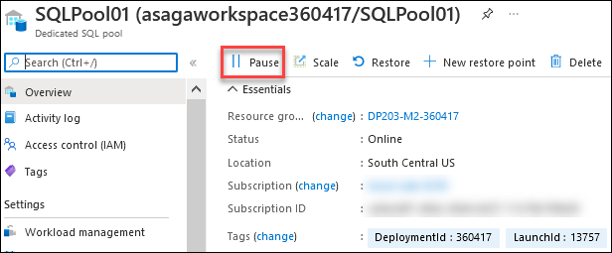

## Best Practices:

1. Stop the VM when not in use. Similarly Pause the SQL pool whenever it is not in use to optimize the azure cost.
2. If you face issue loading VM, please do the following:

* Check if VM is in running state from the Virtual Machines tab.
* Try to open the environment URL in incognito/ private window.
* Accept the cookies to the site (cloudlabs.ai)
* Try to open it in a different browser.

1. Copy/ Paste issue
   * Click on the SSL certificate symbol at the top left corner. Open pop-up change the clipboard dropdown to allow.
   * Once clipboard access is enabled, you can use CTRL+C to copy and CTRL+V to paste inside the VM. You can also try copying by right click > Copy on the selected content.

## Lab Guide preview:

If you want to experience the module guides without launching the lab environment as instructed above, you can use below preview links. Following preview links are designed to get you access to module guides without starting the lab environments and timer.

|  |  |  |
| --- | --- | --- |
| Lab Environment | Modules Included | Preview Link |
| Lab 1 | 1,6,15 ,17 | [Click Here](https://experience.cloudlabs.ai/#/labguidepreview/98a6adb1-5370-4868-bd6b-f23afa1ee69c) |
| Lab 2 | 2 | [Click Here](https://experience.cloudlabs.ai/#/labguidepreview/82ebdcfd-a87d-43eb-922d-7614223c77b2) |
| Lab 3 | 4,5,7,8,9,10,11,12,13,16 | [Click Here](https://experience.cloudlabs.ai/#/labguidepreview/7dcf4fda-a310-4289-8619-2628fb763b07) |
| Lab 3 | 14 | [Click Here](https://experience.cloudlabs.ai/#/labguidepreview/50666f9d-757e-48c8-ae62-17ff87f609f6) |